This is the step to create a wrapper through template provided by system.

Open Template
- Go to the File menu, select Open, and then select the Wrapper Templete.
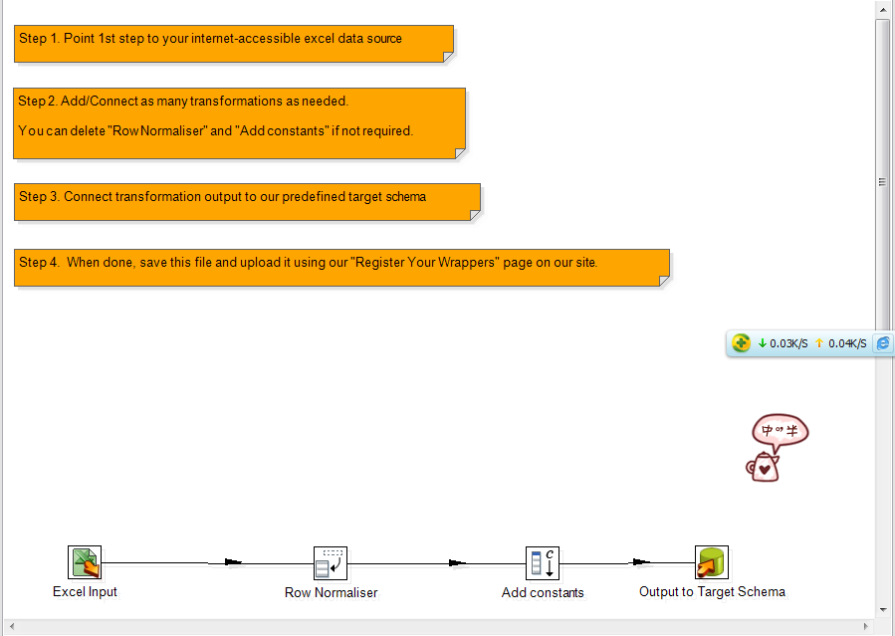
- Go to the File menu, select Save as, and specify the name of your own wrapper. For example, save the wrapper as B13.
- A window appears where you can specify Transformation properties. In this case, a description, then click Save.
- This will create a B13.ktr file.
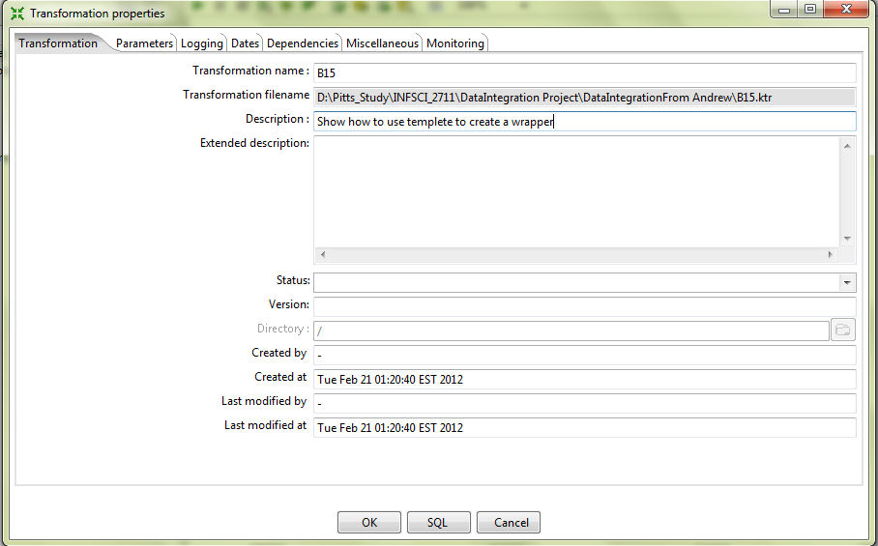

Modifying the Excel file input Step
- Double-click on the Excel file input Step.
- The configuration window belonging to this kind of Step will appear. Here you'll indicate the location, format and content of the input file.
- In the Filename field, type the name and location of the input file or browse the file locally. Press “Add”, location of selected filename will be displayed in Selected files field.
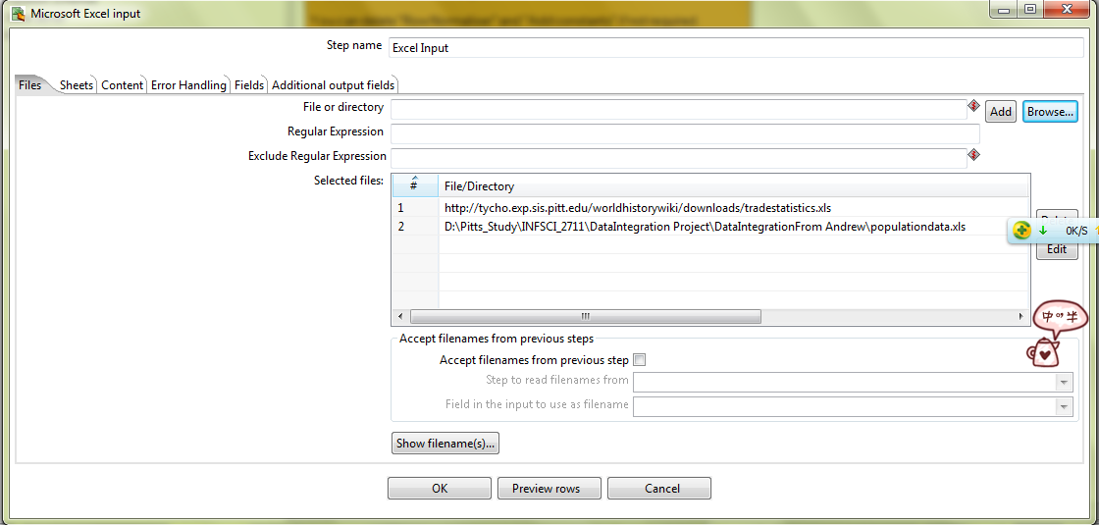
- Go to Sheet page, and Click Get sheetnames to add B13 sheet to the grid. Specify the Start row and Start column of related table in B13 sheet. Delete unrelated sheet.
- Go to Field page, and click Get fileds from the star row to add the fields in B13 sheet to the grid.
- Replace the second field name “Slave-trade region” with “SlaveTradeRegion”, as space is not database friendly.
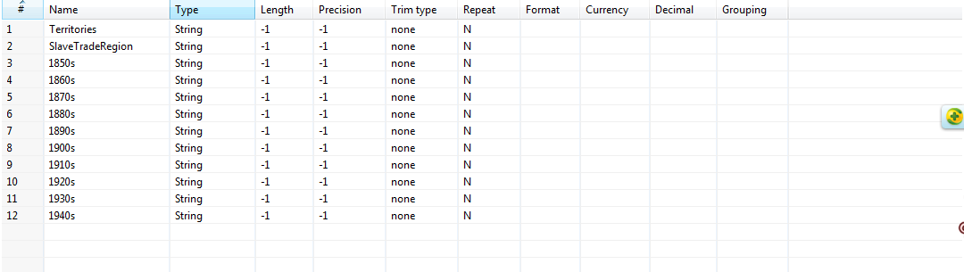
- Click OK to finish defining the Step Excel file input.

Modifying the Row Normaliser Step
- Double-click on the Row Normaliser Step.
- The configuration window belonging to this kind of Step will appear.
- Click Get fileds. A window appears where you choose clear and add all to add field from the previous steps to the grid.
- Fill in Value into the new field column for each Fieldname.
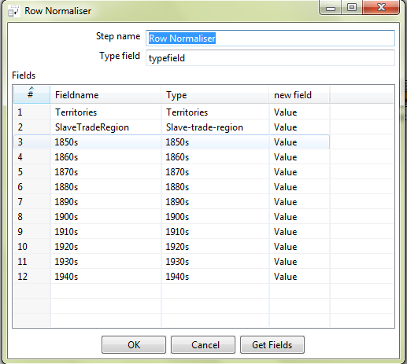
- Click OK to finish defining the Step Row Normaliser step.

Launching the Wrapper
- Before executing the Transformation, check that everything is properly configured by clicking Verify button in the workspace menu. Spoon will verify that the Transformation is syntactically correct, and look for unreachable Steps and nonexistent connections. If everything is in order (it should be if you followed the instructions), you are ready to preview the output.
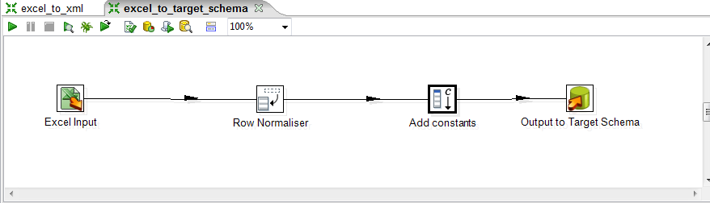
- Click Run button in the workspace menu.
- Spoon will show a window where you can set, among other information, the parameters for the execution and the logging level. Click Launch.
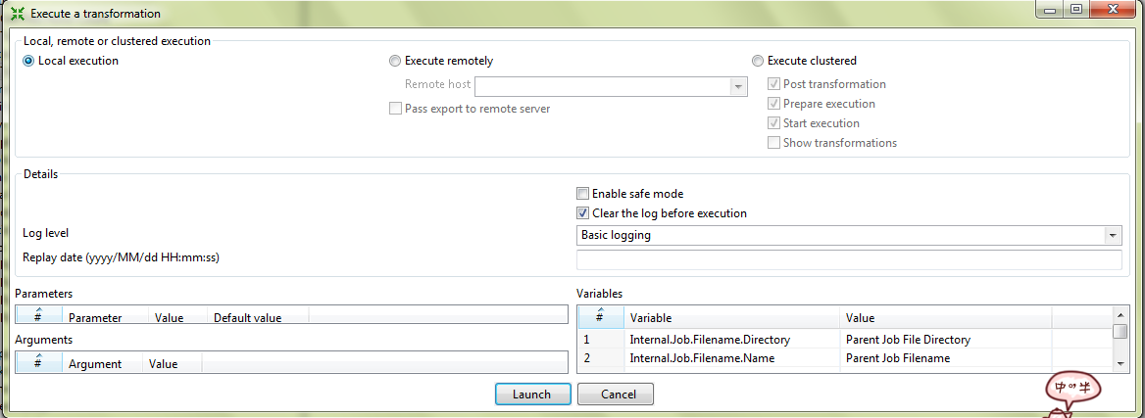
- A new window appears requiring save the transformation. Click Yes.
- A new window tab will appear in the Job window. This is the log tab, which contains a log of the current execution.
